# RSI-Based Signal Merge and Plot (Final Version)

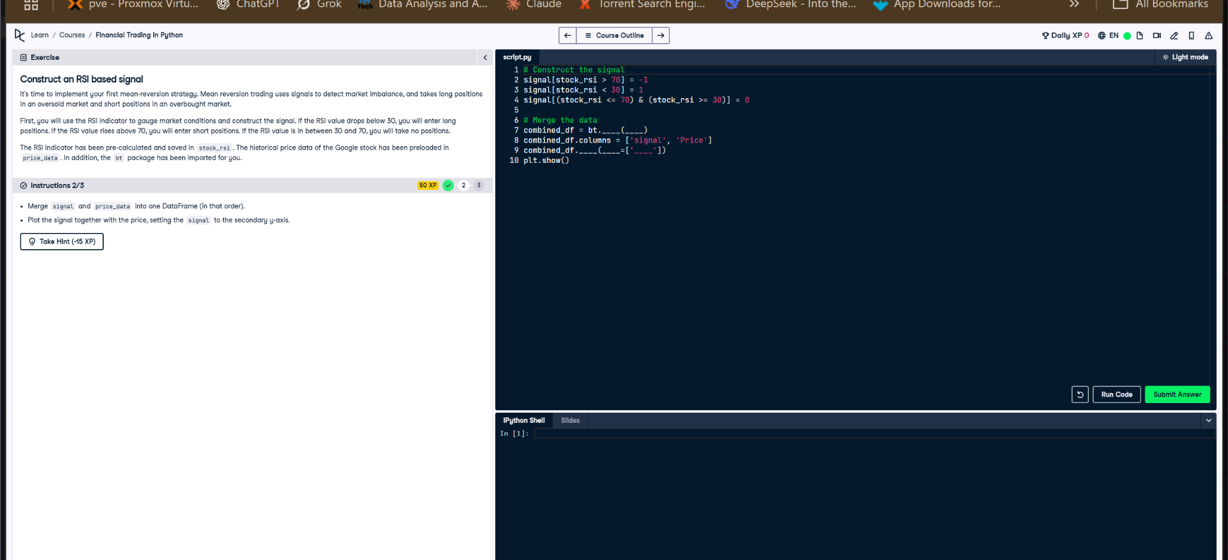

Figure: Exercise for merging RSI signal and plotting with secondary axis.

## Python Code

# Construct the signal  
signal[stock_rsi > 70] = -1  
signal[stock_rsi < 30] = 1  
signal[(stock_rsi <= 70) & (stock_rsi >= 30)] = 0  
  
# Merge the data  
combined_df = bt.merge(signal, price_data)  
combined_df.columns = ['signal', 'Price']  
  
# Plot with secondary y-axis for signal  
combined_df.plot(secondary_y=['signal'])  
plt.show()

## Explanation

This code constructs an RSI-based signal, merges it with stock price data, and plots the result. A sell signal (-1) is set when RSI > 70, and a buy signal (1) is set when RSI < 30. `bt.merge()` combines both series into one DataFrame. The plot uses a secondary y-axis to clearly show the signal alongside the stock price.

## AI-Generated Hint

Have you checked if you are merging the signal and price_data DataFrames correctly and setting the signal to the secondary y-axis in the plot?  
  
# Example of merging two DataFrames  
combined_df = bt.merge(signal, price_data)  
  
# Example of plotting with a secondary y-axis  
combined_df.plot(secondary_y=['signal'])  
plt.show()